Zoom & Backup Recording Standards

RECORDING THE EVENT (BOTH VIDEO AND AUDIO) IS YOUR #1 PRIORITY!

Always triple check that you are recording when on the record -

Zoom recording: This recording is your main recording that will be delivered to the client. You are to go on/off the record (PAUSE RECORDING) on the ZOOM recording whenever you go on break. This will mean you are creating one continuous video file for the client.

Backup recording: This recording is an audio/video backup recording of everything. Press record before the event begins and stop recording before you leave for the day.

Zoom Recording Step-by-Step:
The Zoom recording is your main recording. You will be going off and on the record during breaks on the ZOOM RECORDING. Here is how:

VERIFY FIRST: | - Witness has been SPOTLIT in Zoom  - You are host of the event  - You have turned the Zoom transcript ON  - Backup recorder is RECORDING
To start recording | Press RECORD button 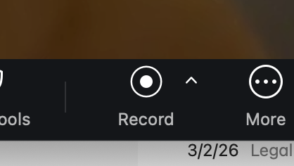
 | Choose “Record to cloud”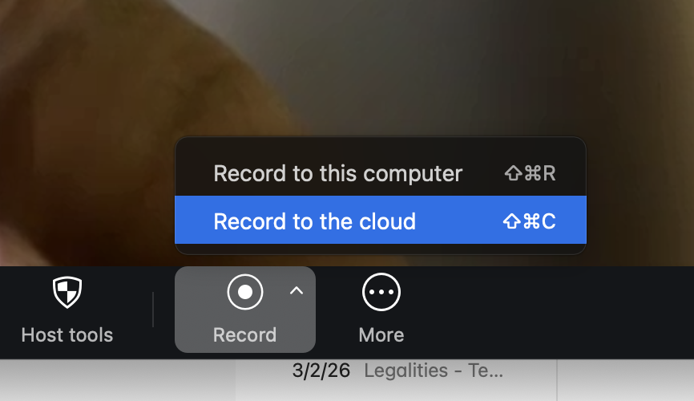
 | You should hear “recording in progress” audio
To go on break | Press record button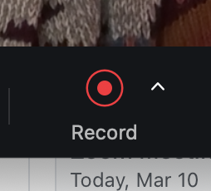
 | Press “Pause Recording”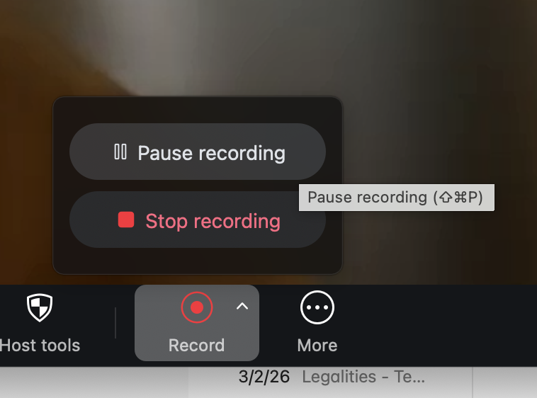
 | You should hear “Recording stopped” audio
To come back from break | Press record button
 | Press “Resume Recording” 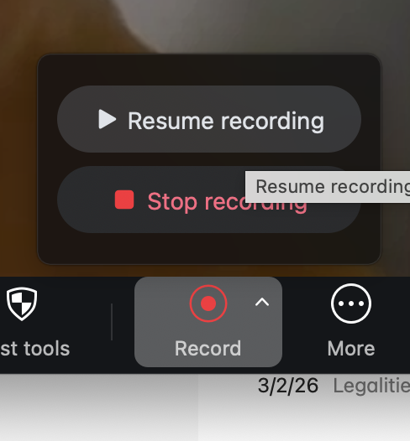
 | You should hear “Recording in Progress” audio
To end the deposition (stop recording for the day) | Press Record button
 | Press “stop recording”
 | You should hear “Recording stopped” audio

Backup (OBS) Recording Procedure:
Once you arrive | Press record (Both video/audio) anytime before the deposition begins
LEAVE RUNNING THE ENTIRE DEPOSITION. EVEN ON BREAKS.
Before leaving for the day | Turn recording off.

